Dockerized OKAPI information retrieval system
An Agile Approach of setting up information retrieval system

Author: Zhi Xu
Supervisor: Dr. Jimmy Huang

A RESEARCH PROJECT SUBMITTED TO
THE FACULTY OF GRADUATE STUDIES
IN PARTIAL FULFILMENT OF THE REQUIREMENTS
FOR THE DEGREE OF
MASTER OF ARTS

GRADUATE PROGRAM IN INFORMATION SYSTEMS AND TECHNOLOGY
YORK UNIVERSITY
TORONTO, ONTARIO
2016

Abstract
We describe the easy adaption and development by using a highly complex and very robust IR system, Okapi BM25 system [1]. The objective of this paper is to demonstrate an agile design & approach which optimizes and automates the Okapi system build & deployment process. This research project utilizes the most well-known, open-source, light-weight container tool, which is named Docker, to demonstrate the agile approach of setting up Okapi BM25 IR System research methodology in Ubuntu environment with sharing of exchange data files in Google Cloud. By the help of this project, a tremendous amount of time could be saved for researchers who utilize Okapi BM25 IR System to perform information retrieval, since all prerequisites of Okapi system could be downloaded and setup by the customized Docker-File which comes along with the installation package of this project.

Our goal is to increase efficiency and effectiveness of Okapi development and allow academic researchers to easily adapt the Okapi system, and conveniently present & share research results. In order to pre-process the raw data, an open-source ETL and data integration tool named Talend Data Integration is used to convert different kinds of raw data into Okapi exchange format which Okapi BM25 IR System could read.

In addition, taking the advantage of Google Drive, exchange data file of Okapi BM25 could be uploaded to Cloud and shared to specific user, which significantly increased efficiency and effectiveness of Okapi BM25 IR System.

Acknowledgements
This research was supported by Dr. Xiangji (Jimmy) Huang. I truly appreciate his inspiration and guidance throughout the project. His solid understanding on information retrieval (IR) field and persistent on perfecting the Okapi BM25 IR System kept me going along the road. Being a student who worked with Dr. Huang since undergraduate study, I’ve always been impressed and helped by different types of research projects he leads. It’s his encouragement and help led me into this program and greatly helped in advancing my professional career development.

In addition, I would like to thank Tom Wu, Xiaoli Hu and Tian Yang for their companionship in past 3 years of academic graduate study and professional work life. It’s unimaginable to study and work without them.

Table of Content
Abstract 2
Acknowledgements 3
1. Introduction 7
2. Area of Improvement 8
Application migration 8
Usability 8
Exchange file sharing 8
3. Requirement Analysis 9
Purpose of the System 9
Core System Functionalities 9
Functional Requirements 9
4. Architecture Design 10
Tools 11
Talend 11
Docker 11
5. Implementation 11
Prerequisite 11
Create Docker file to build Docker image 11
Set the base Docker image to Ubuntu 12
Set File Author / Maintainer 12
Install Okapi dependencies and copy header files 12
Create directories 13
Add Index file and search script 13
Copy Index file and search script 14
Compile Okapi 14
Change work directory 14
6. Run Okapi on Windows 15
Operation System 15
Prerequisite 15
Download and install Docker 15
Download and unpack application package 18
Unpack application package 19
Place an Okapi exchange format file into Okapi environment 19
Run Docker as Administrator on Windows 20
Use Docker file to build Docker image 20
Run Okapi 22
Launch Docker image 22
Search in Okapi 26
Add new exchange file to Okapi 26
7. Run Okapi on Ubuntu 32
Operation System 32
Prerequisite 32
Update apt sources 32
Install Docker 36
Install google-drive-ocamlfuse on Ubuntu – (Optional) 38
Unpack application package 40
Place an Okapi exchange format file into Okapi environment 41
Generate parameter files and running script 41
Use Docker file to build Docker image 42
Run Okapi 43
Launch Docker image 43
Search in Okapi 45
Add new exchange file to Okapi 46
Mount Google Drive folder 47
8. Use Talend to Generate Okapi Exchange file 48
Install Talend 48
Import Talend project 49
Setup Contexts 51
Execute jobs for dataset 54
Sample Clean up job: FileProcess_0_CleanUp 56
Sample split job: FileProcess_1_Split_AP88_89 59
Sample process job: FileProcess_2_Process 61
Sample combine job: FileProcess_3_Combine 64
Customize split job for different dataset 66
Execute jobs by using scripts 67
9. Conclusions 68
10. Future Work 69
REFERENCES 70

Introduction
Okapi BM25 system is a full-featured information retrieval system, which has been using by many academic researchers to index, weight and retrieve various kinds of documents since 1980s [2], but it has a very steep learning curve, especially for those who have limited Unix and C experience. Based on the probabilistic retrieval model, the Okapi information retrieval system has proved its value by being able to provide highly relevant documents related to the given search query. However, being an information system which is originally designed and implemented in 1980s, it lacks some key features which many modern information retrieval systems have. One of these features is being environment neutral and smooth learning curve. Unlike many modern information retrieval systems which are implemented by environment neutral programming language, such as Java, Okapi is implemented by C language and has only UNIX and Linux versions. Okapi has a very steep learning curve, especially for those who have limited UNIX and C experience. It is common for an inexperience Okapi user to spend several days/weeks to prepare Okapi runtime and build environment and post documents to it, not to mention compiling C code and generating indexes efforts [3].

Historically, it is very difficult to migration Okapi system from one operating system to the other or from one machine to the other [4]. Based on our previous experience working with Okapi system, it lacks mobility, hard to duplicate existing environment, and forces new users spend several days or weeks on building new Okapi environment on local environment. We see some main benefits from our re-defined system/workflow:
- Researchers can easily setup Okapi System in Window or Linux without long overhead. By adapting agile approach, users can easily commit changes and with better collaboration with the team
- New system allows data, inverted index, configuration and outcome be easily shared among team members and other peers and researchers
- Most importantly the workflow can be applied and adapted by any other IR systems and applications for faster and efficient research purpose

Area of Improvement

Application migration
The system could be migrated to Linux and Windows Operation system.

Usability
Researchers can easily setup Okapi System in Window or Linux without long overhead.

Exchange file sharing
By utilizing Google Cloud, Okapi Exchange files could be easily shared to other person.

Requirement Analysis

Purpose of the System
The purpose of the system is to help user setup Okapi System in Linux and Windows environment.

Core System Functionalities
- Execute in Windows environment
- Execute in Linux environment
- Read raw data and generate Okapi Exchange format file
- Minimize Okapi configuration

Functional Requirements
- This system must be able to generate Okapi index file
- This system must be able to add Okapi index file to database
- This system must be able to search key words on Okapi database
- This system must be able to display or print search result

Architecture Design
We choice Talend Data Integration Solution as the tool based on the following benefits:
- Central metadata repository and Cross-platform, it is based on Eclipse project with Eclipse-based programing IDE and Java code generator and viewer
- Flat learning curve for java developers and anyone with Eclipse experience. It has configurable metadata to adjust project settings and user friendly for all levels of users
- Routines written in java class could be used to control job behaviour. Other IR systems and applications can use the classes
We started improving the workflow by creating better source control management. The Okapi source code is managed by using Talend Data Integration Solution. The new commits can be pushed to Talend then create Pull Requests to merge develop into master for stable builds.
We then created the ETL processes to build a complete Okapi system readable output file. Figure 1 shows overview of architecture design of the new workflow.

Figure 1: System Overview
The raw data is processed by Talend jobs and converted into data file with Okapi exchange format which Okapi system can read. Okapi system which is running in Docker container reads these exchange files and generated corresponding index files for the searching.

Tools

Talend
Talend (Pronunciation: TAL-end) is a software vendor specializing in Big Data Integration. The company provides big data, Cloud, data integration, data management, Master Data Management, data quality, data preparation and enterprise application integration software and services [5].

Docker
Docker is the most popular and the world’s leading software containerization platform.

Implementation

Prerequisite
There are two versions of Okapi available now, which are Solaris version and Linux version. Since Docker doesn’t have Solaris image, we are going to use Linux version Okapi to build Docker image.

Create Docker file to build Docker image
Docker can build Docker images automatically by reading the instructions from a text-based file, which is called Dockerfile. Dockerfile is a plain text file that contains Docker commands.
A Dockerfile contains instructions in this format:
# Comment
INSTRUCTION arguments

Set the base Docker image to Ubuntu
A valid Dockerfile's first non-comment line will be a FROM instruction. The FROM instruction is used to set the base image for subsequent instructions in Dockerfile and the image can be any valid image. Therefore, a valid Dockerfile must have FROM as its first instruction.

In this project, Ubuntu version 14.04 is used as base image.
# Set the base image to Ubuntu
FROM ubuntu:14.04

Set File Author / Maintainer
The MAINTAINER instruction allows you to set the author for the generated images:
# File Author / Maintainer
MAINTAINER Zhi Xu

Install Okapi dependencies and copy header files
The RUN instruction will execute any command in a new layer on top of the current image, and commit this image. The image thus committed will be used for the next instruction in the Dockerfile.
In this project, following packages/tools need to be installed into image: gcc, libc6-i386, make, bison, flex, openjdk, git and vim.
# Pre-requisite for compiling Okapi
RUN dpkg --add-architecture i386 && \
apt-get update && \
apt-get install -y \
gcc \
gcc-multilib \
libc6-i386 \
make \
bison \
flex \
openjdk-6-jdk:i386 \
git \
vim && \
rm -rf /var/lib/apt/lists/* && \
cp /usr/lib/jvm/java-1.6.0-openjdk-i386/include/jni.h /usr/lib/gcc/x86_64-linux-gnu/4.8/include && \
cp /usr/lib/jvm/java-1.6.0-openjdk-i386/include/jni_md.h /usr/lib/gcc/x86_64-linux-gnu/4.8/include

Create directories
Several directories need to be created for later use. In order to create these folders, Linux command “mkdir” could be used.
- /home/okapi -- okapi root folder
- /home/okapi/InputData -- okapi index file folder
- /home/okapi/SearchScripts -- okapi customized search script folder

RUN mkdir -p /home/okapi && \
mkdir -p /home/okapi/InputData && \
mkdir -p /home/okapi/SearchScripts
Folder “InputData” will be used to keep okapi index file.
Folder “SearchScripts” will be used to keep customized search script file, which will search against the okapi index file.

Add Index file and search script
The ADD instruction is used to copy files into the image. In following code snippet, three folders in current directory will be copied into image.
- Copy folder “okapi” in current directory into folder “/home/okapi” in image
- Copy folder “InputData” in current directory into folder “/home/okapi/InputData” in image
- Copy folder “SearchScripts” in current directory into folder “/home/okapi/SearchScripts” in image
ADD okapi /home/okapi/
ADD InputData /home/okapi/InputData/
ADD SearchScripts /home/okapi/SearchScripts/

Copy Index file and search script
The Okapi data file will be copied into “input” folder while customized script will be copied into “scripts” folder.
Run cp /home/okapi/InputData/* /home/okapi/input && \
cp /home/okapi/SearchScripts/* /home/okapi/scripts

Compile Okapi
In this step, files in “/home/okapi/bin folder” will be assigned with full access permission. Some Java class files will be compiled into Java classes. In addition, a script named “init.sh” will be executed to initialize Okpai environment.
Run chmod 777 /home/okapi/bin/* && \
javac /home/okapi/javasrc/*.java -d /home/okapi/javabin && \
bin/bash /home/okapi/scripts/init.sh

Change work directory
The WORKDIR instruction sets the working directory of Dockerfile commands that follow it for the RUN, CMD, and ENTRYPOINT. This instruction can be used multiple times in the same Dockerfile.
In this step, the working directory of image is set to “/home/okapi”. Once the image is up and running, the default working directory of Docker image is “/home/okapi”.
WORKDIR /home/okapi

Run Okapi on Windows

Operation System
In this section, we are going to demonstrate how to setup and execute the system on Windows.

Prerequisite

Download and install Docker
Download and install Docker ToolBox by using following URL:
https://www.docker.com/products/docker-toolbox
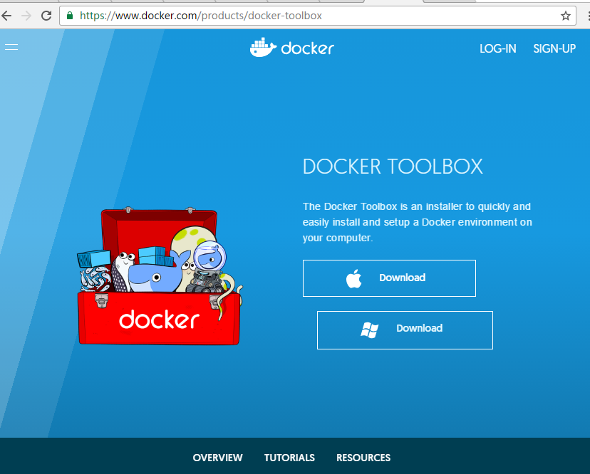

Execute installation package to install Docker Toolbox.
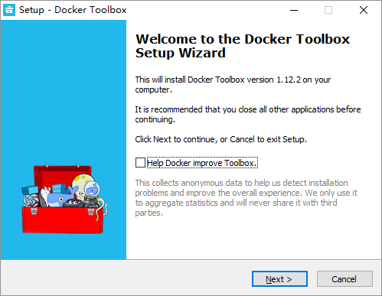

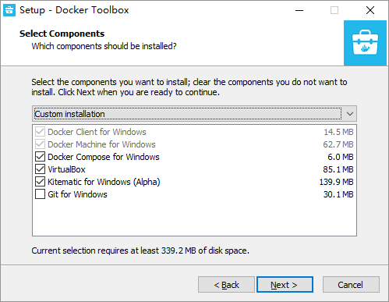

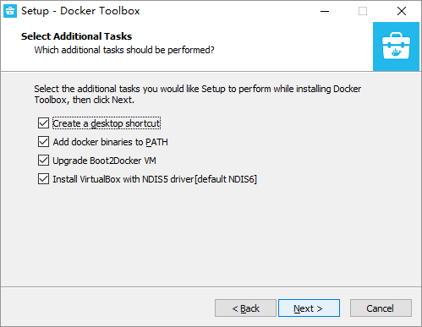

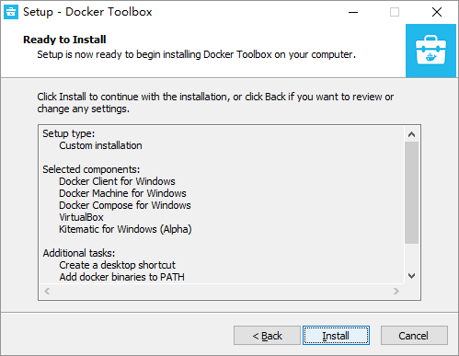

Download and unpack application package
Download and unpack Docker application package by using following URL from GitHub
https://github.com/xuzhii/okapi
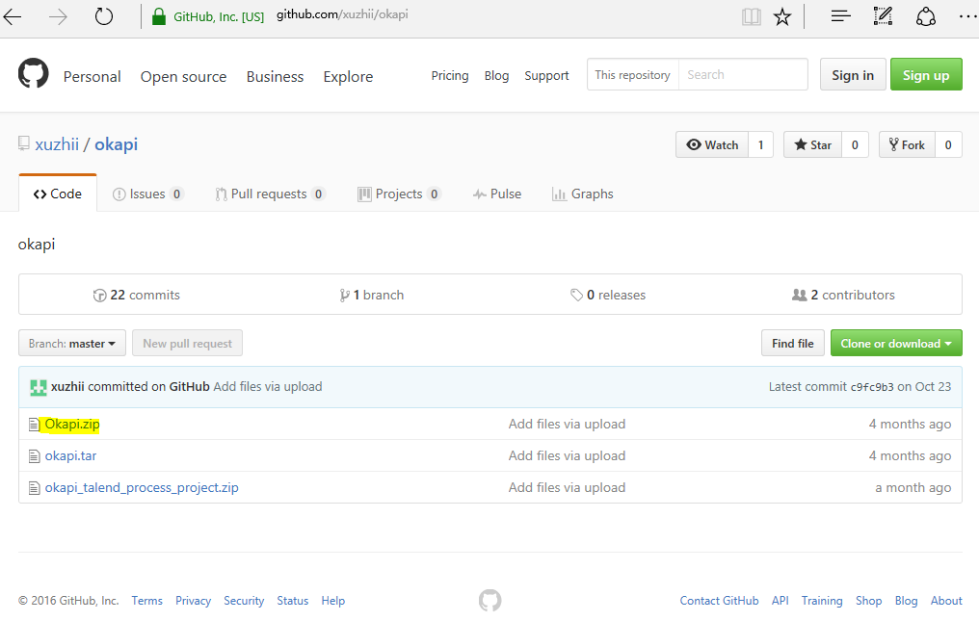

Unpack application package
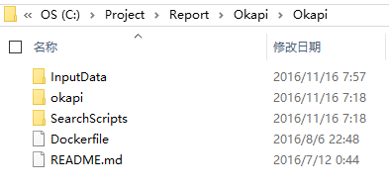

Place an Okapi exchange format file into Okapi environment
Due to security reason, place exchange format file into a folder under current Windows user’s folder, such as “C:\Users\XiaoTu”.

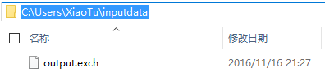

Run Docker as Administrator on Windows

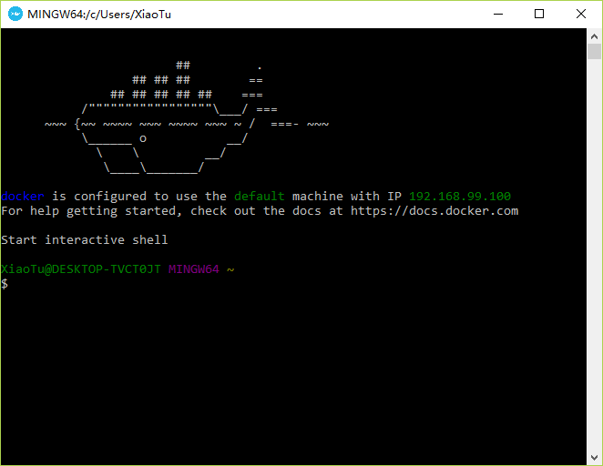

Use Docker file to build Docker image
Change current working directory to folder with Docker file and run Docker build command to create Docker image. “Dockerized-okapi” is the tag name of the Docker image which could be referred when running this Docker image.

cd /c/project/Report/okapi/okapi
ls

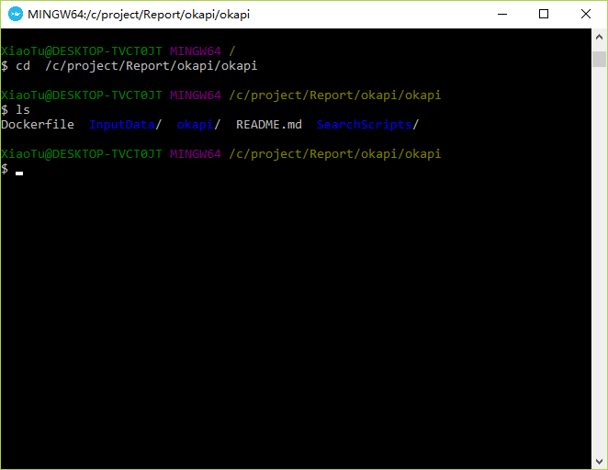

docker build –t “dockerized-okapi” .

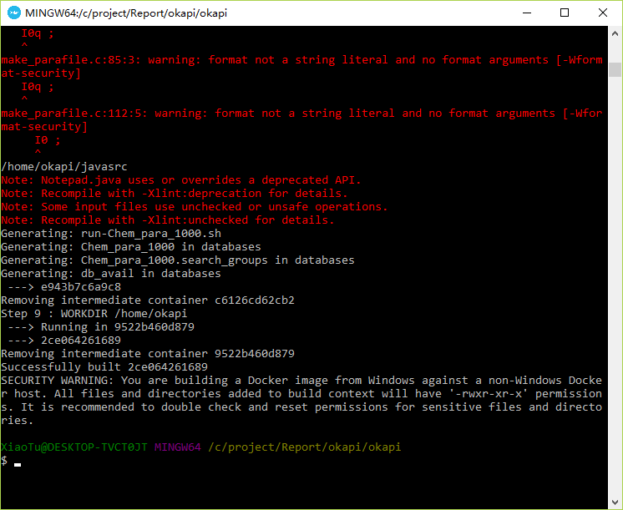

Run Okapi

Launch Docker image
Run Docker image is as simple as running following command in current folder.
docker run -i –t dockerized-okapi bash

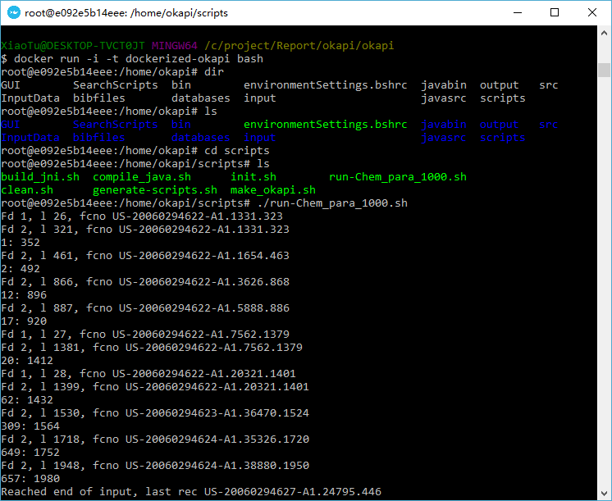
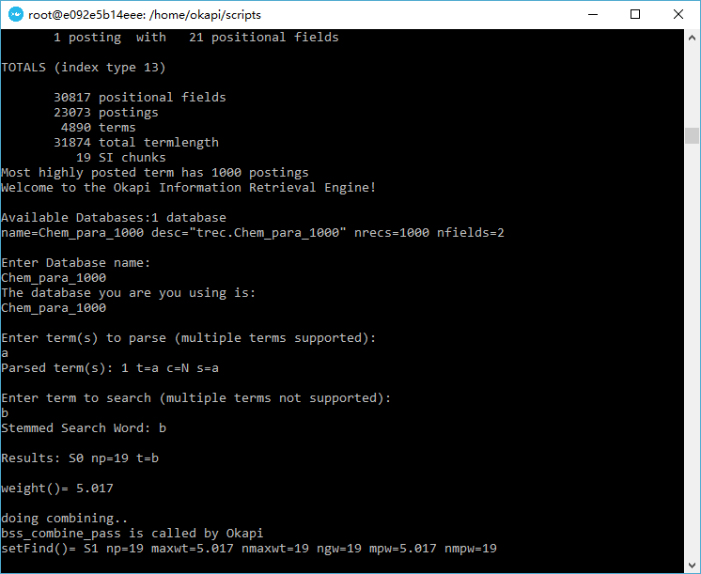

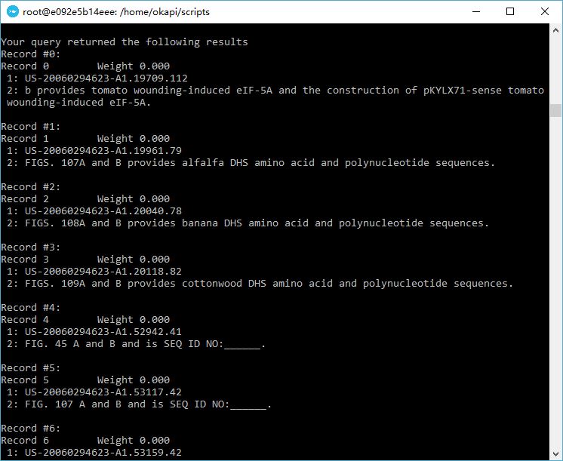

docker run -i -t -v /c/Users/XiaoTu/inputdata:/home/okapi/input dockerized-okapi bash
If new Okapi exchange file with large volume needs to be added into Docker image, run Docker image with –v flag to mount a host folder to container folder. Run Docker image with folder mount is as simple as running following command in current folder.
This command will mount folder “C:\Users\XiaoTu\inputdata” on Windows to “/home/okapi/input” in Docker container. Once the folder is mounted, the files in host folder could be accessed in container as files in mounted folder.

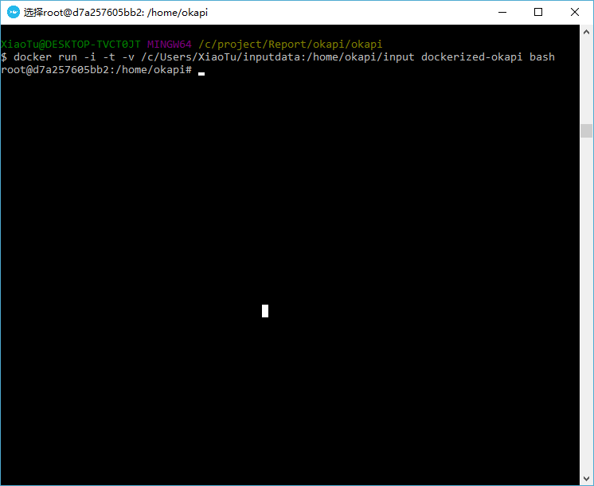
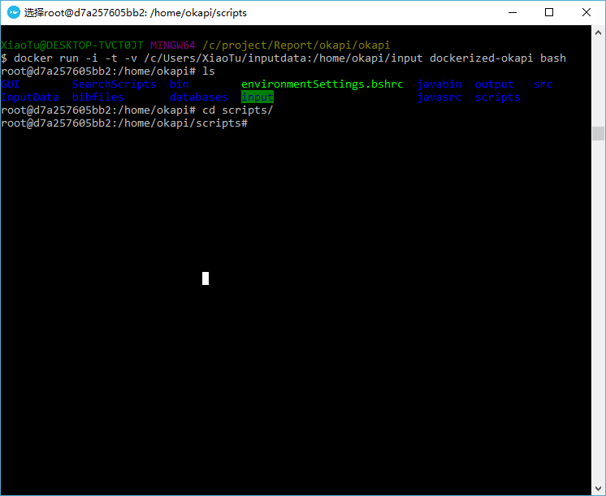

Search in Okapi
Once Docker container is up and running, Dockerized Okapi is available for searching. The default working directory has been set to “/home/okapi” in the Docker file. In order to run search script, change current working directory to “scripts” and run running script.
cd scripts
./run-Chem_para_1000.sh

Add new exchange file to Okapi
If the Docker image is running with mount folder, new exchange file could be added to Okapi database list while Docker container is up and running. In the previous example of “Run Docker image with folder mount”, the folder named “C:\Users\XiaoTu\inputdata” on Windows has been mounted to “/home/okapi/input” in Docker container. Adding an Okapi exchange file to this specific host folder, the exchange file will show up in mount folder in Docker container. There is a script named “generate-scripts.sh”, which will read “/home/okapi/input” folder in Docker container and generate parameter files and running script for all exchange files in this folder.
./ generate-scripts.sh
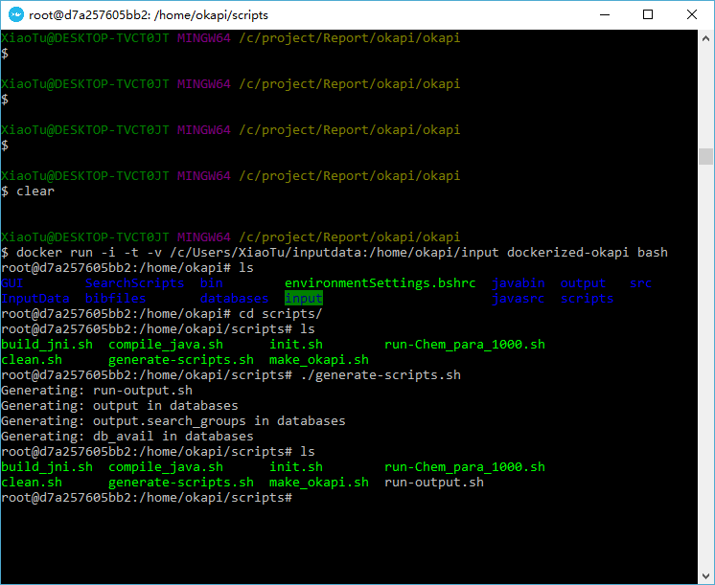
After the new script is generated, use chmod to assign execute permission to this new script and execute it.
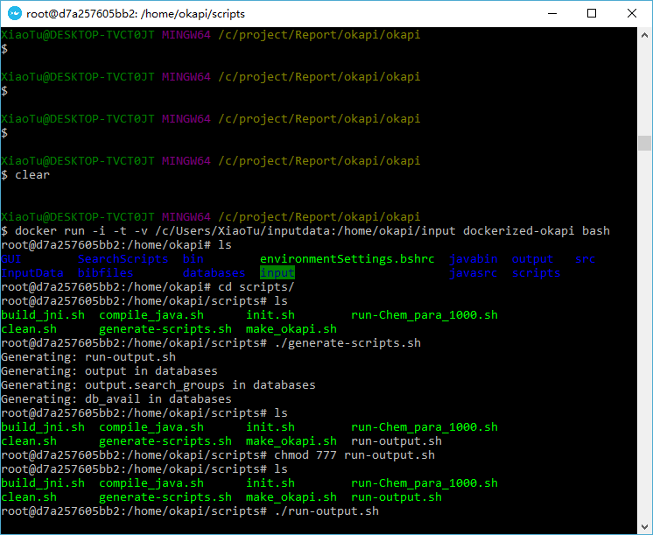
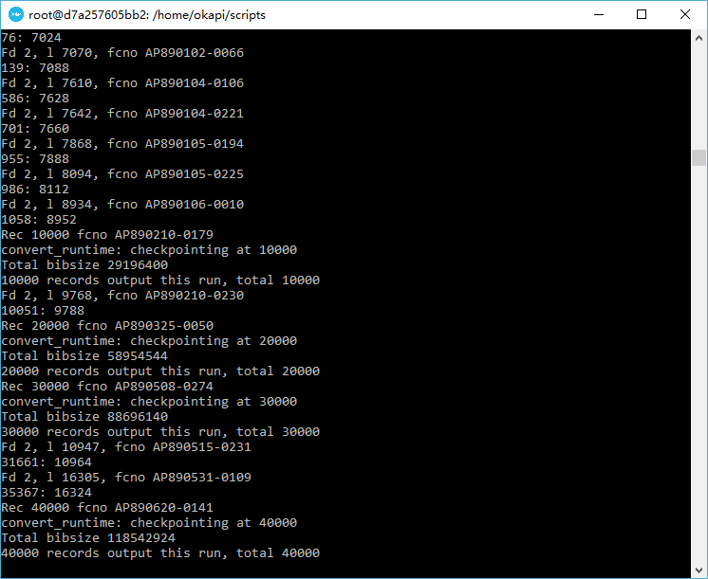
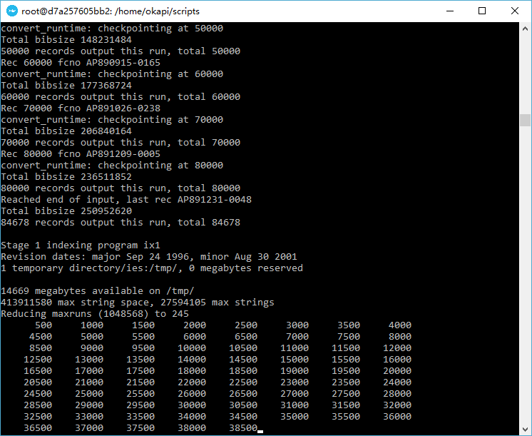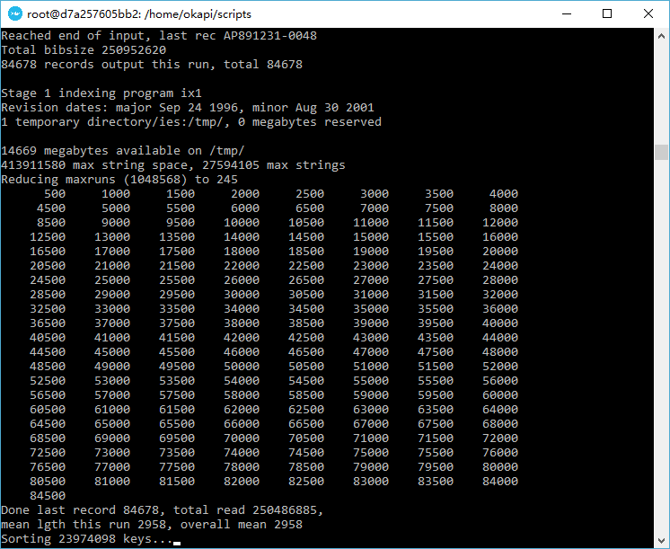
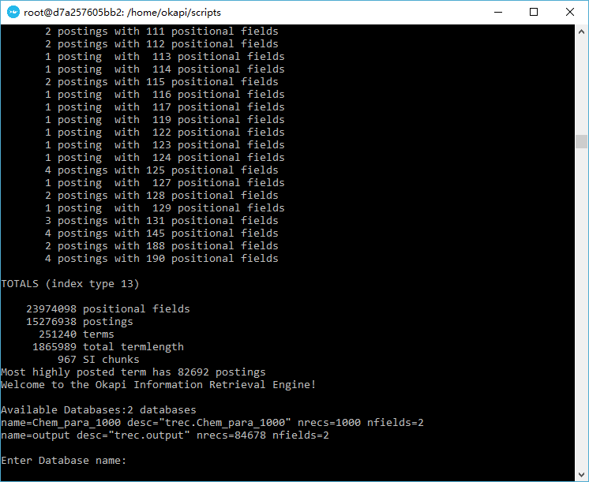
Choose database name, which is same to the exchange file name.
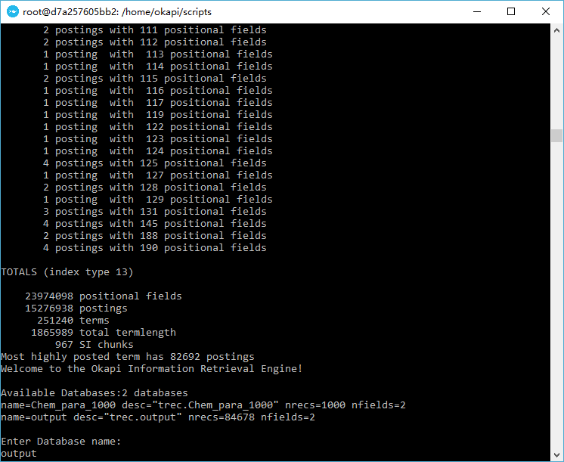
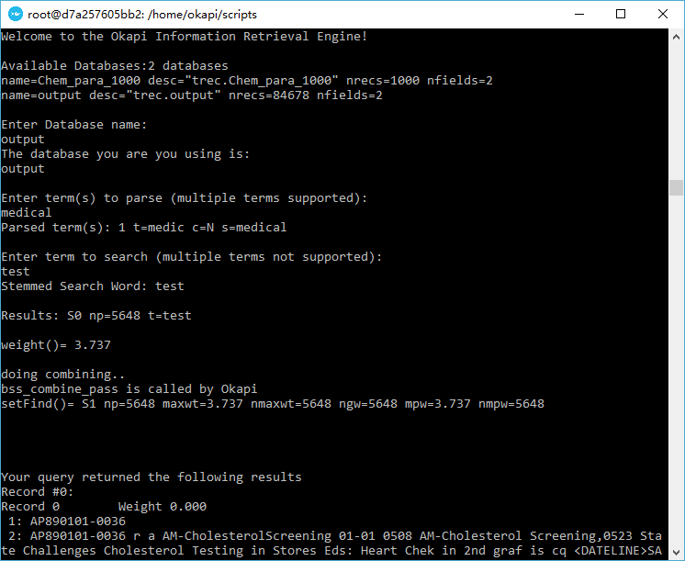

Run Okapi on Ubuntu

Operation System
In this section, we are going to demonstrate how to setup and execute the system on Ubuntu.

Prerequisite

Update apt sources
Regardless of the Ubuntu version, Docker requires a 64-bit installation. In addition, the kernel of Ubuntu must be 3.10 or a newer version. In order to check the current kernel version of Ubuntu, open a terminal and use uname -r to display kernel version:
$ uname -r
4.4.0-21-generic

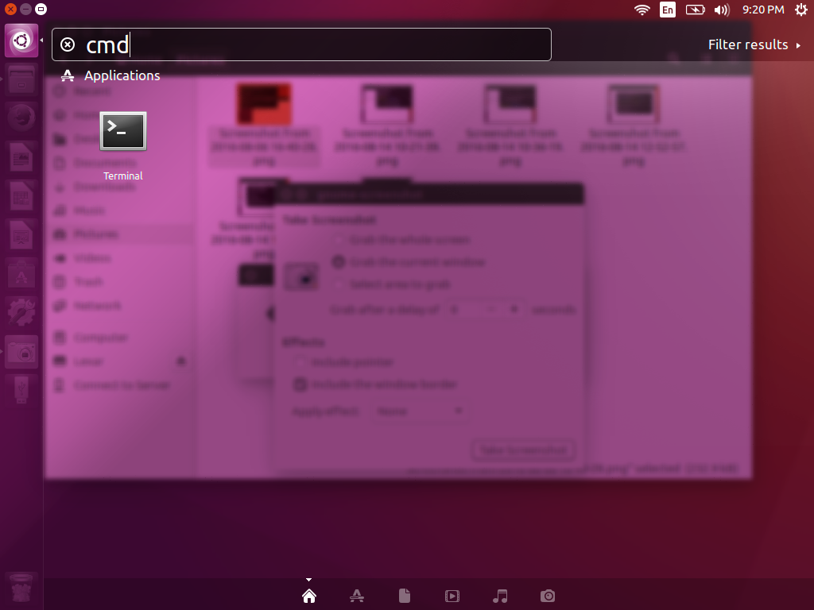
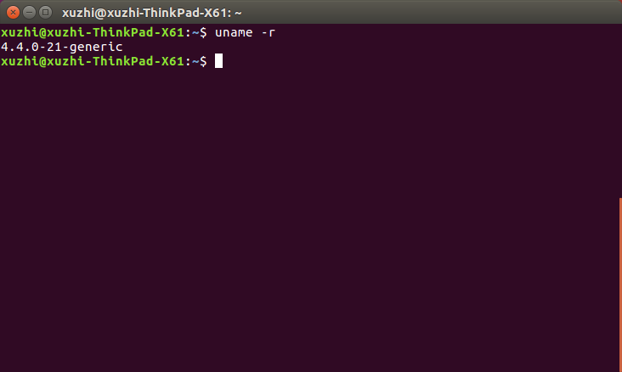

- Log into your machine as a user with sudo or root privileges.
- Open a terminal window.
- Update package information to ensure that APT works with the https method, and that CA certificates are installed.
$ sudo apt-get update
$ sudo apt-get install apt-transport-https ca-certificates

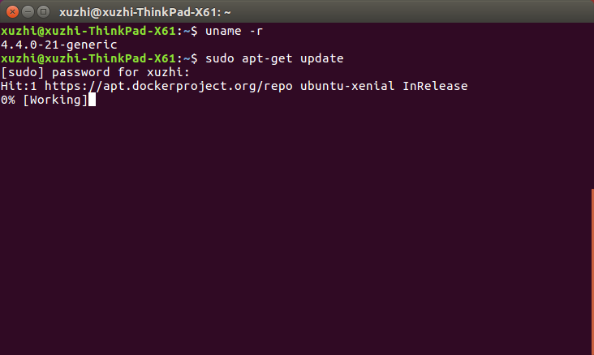
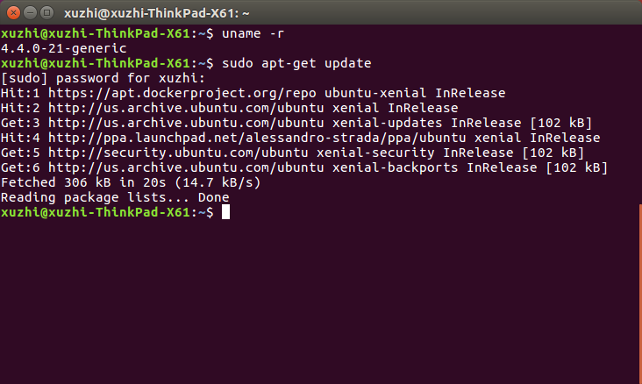
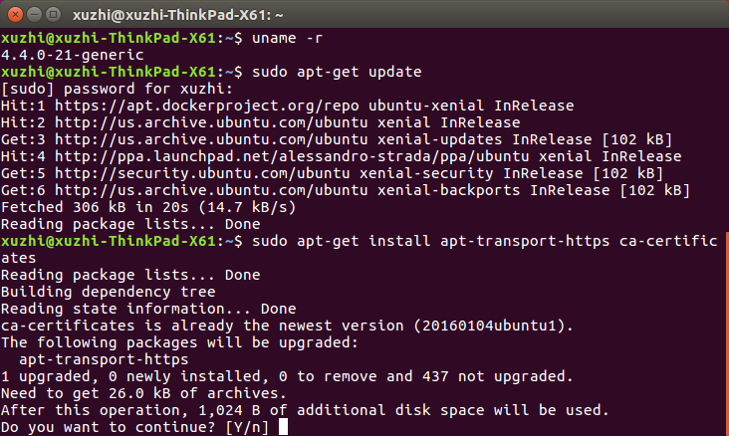

- Add the new GPG key.
$ sudo apt-key adv --keyserver hkp://p80.pool.sks-keyservers.net:80 --recv-keys 58118E89F3A912897C070ADBF76221572C52609D

- Open the /etc/apt/sources.list.d/docker.list file in text editor. If the file doesn’t exist, create the file.
- Remove any existing entries.
- Add an entry for the Ubuntu operating system.
The possible entries are:
Ubuntu Wily 15.10
deb https://apt.dockerproject.org/repo ubuntu-trusty main

deb https://apt.dockerproject.org/repo ubuntu-xenial main
Ubuntu Xenial 16.04 (LTS)

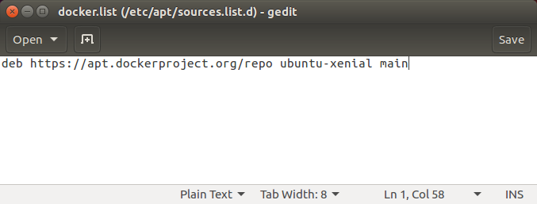

- Save and close the /etc/apt/sources.list.d/docker.list file.
- Update the APT package index.
$ sudo apt-get update

- Purge the old repo if it exists.
$ sudo apt-get purge lxc-docker
- Verify that APT is pulling from the right repository.
$ apt-cache policy docker-engine

Install Docker
Use following commands to install Docker on Ubuntu
- Log into your Ubuntu installation as a user with sudo privileges.
- Update your APT package index.
$ sudo apt-get update

- Install Docker.
$ sudo apt-get install docker-engine

- Start the docker daemon.
$ sudo service docker start

- Verify docker is installed correctly.
$ sudo docker run hello-world
This command downloads a test image and runs it in a container. When the container runs on Ubuntu, it prints an informational message and exits.

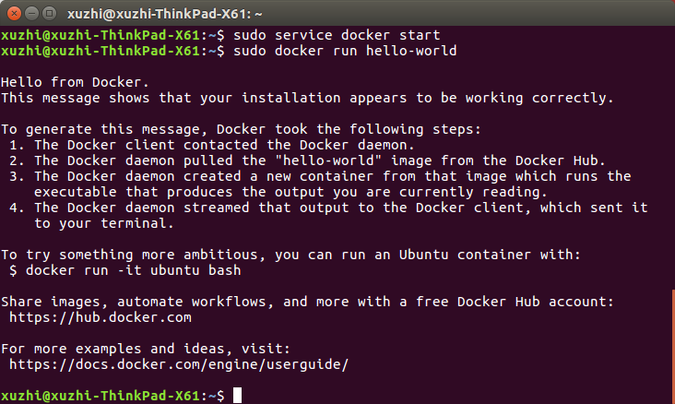

Install google-drive-ocamlfuse on Ubuntu – (Optional)
Google-drive-ocamlfuse is a FUSE file system backend for Google Drive which can be used to mount Google Drive under Linux. It supports full read/write of regular files and folders. Google Drive allows user to edit, share, synchronize and store different kinds of files in the cloud. This section demonstrates how to install google-drive-ocamlfuse on Ubuntu.
- Google-drive-ocamlfuse tool can be easily installed on Ubuntu.
$ sudo add-apt-repository ppa:alessandro-strada/ppa
$ sudo apt-get update
$ sudo apt-get install google-drive-ocamlfuse

- Authorize google-drive-ocamlfuse with your Google account by running following command.
$ google-drive-ocamlfuse
A web page will be opened in the default web browser. The page will ask you to authorize google-drive-ocamlfuse to access Google Drive with your Google account
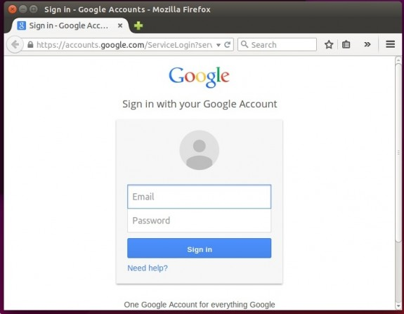
- Sign in Google account with email and password.
- Accept the term and services.
- Allow and give permission to application gdfuse OAuth2 to access your Google account.
- Create mount point such as google-drive in a directory and mount it.
$ mkdir /home/xuzhi/google-drive
$ google-drive-ocamlfuse /home/xuzhi/google-drive

- Check the mount point and disk space usages of mounted Google Drive by using “df” command as shown below.
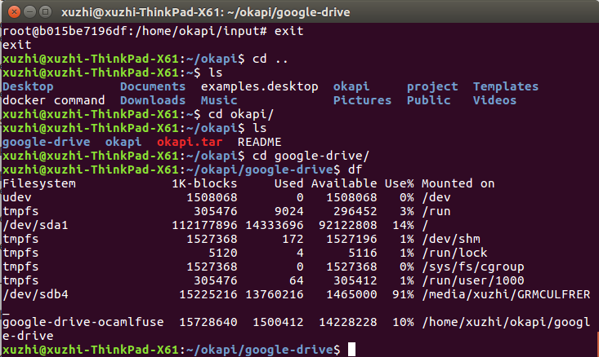
- To unmount the Google Drive, following command could be used
$ fusermount -u /home/xuzhi/google-drive

Unpack application package
- Download application package from GitHub
git clone https://github.com/xuzhii/okapi
- Unzip application package
cd okapi
tar –xvf okapi.tar

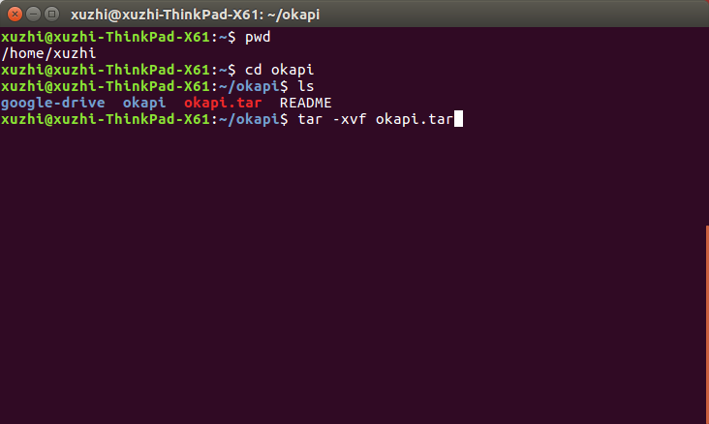
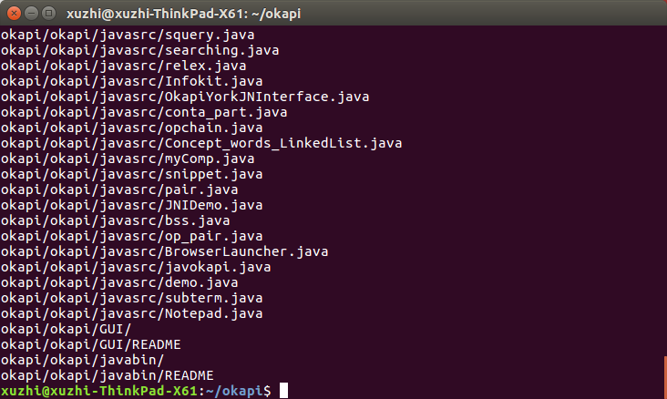

Place an Okapi exchange format file into Okapi environment
- Option one: Copy Okapi exchange format files into “InputData” folder. For example, a sample exchange file named “Chem_para_1000.exch” has been copied to “InputData” in the application package.
- Option two: Mount Okapi exchange format file folder to Docker Image by use “-v” flag when running Docker Image.

Generate parameter files and running script
Dockerized Okapi system comes with a script to generate parameter files and running script automatically. The script is named “generate-scripts.sh”. This script will find all Okapi exchange files in “/home/okapi/input” folder and generate parameter files and running script for all exchange files. For example, an exchange file named “Chem_para_1000.exch” is placed in this folder by default. “generate-scripts.sh” will create two parameter files named “Chem_para_1000” and “Chem_para_1000.search_groups” in “databases” folder in the Docker image. In the meanwhile, update file “db_avail” to append “Chem_para_1000” to available database list.
“generate-scripts.sh” also generates the launcher running script for “Chem_para_1000”. This launcher running script is named to “run- Chem_para_1000.sh”. Once Docker image is up and running, user could use this launcher script to run Okapi system.

Use Docker file to build Docker image
Change current working directory to folder with Docker file and run Docker build command to create Docker image. “Dockerized-okapi” is the tag name of the Docker image which could be referred when running this Docker image.
cd ~/xuzhi/okapi/okapi
sudo docker build –t “dockerized-okapi” .

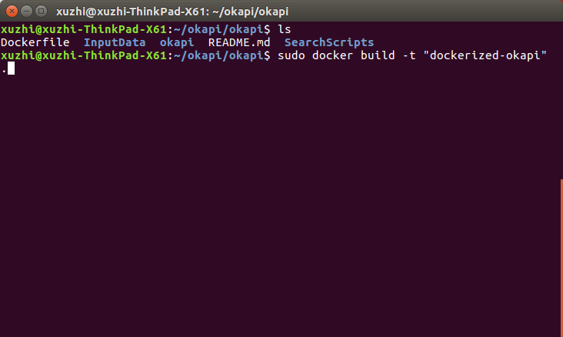
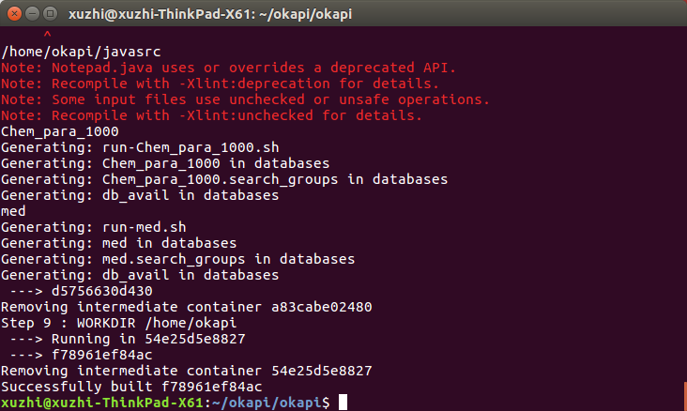

Run Okapi

Launch Docker image
Run Docker image is as simple as running following command in current folder.
sudo docker run -i –t dockerized-okapi bash

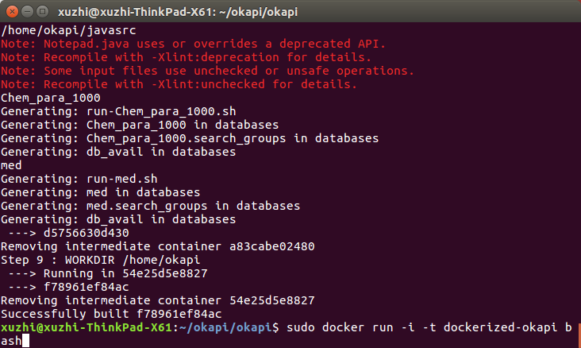

sudo docker run -i –t –v /home/xuzhi/okapi/okapi/InputData:/home/okapi/input dockerized-okapi bash
or
docker run -i -t -v /c/Users/XiaoTu/inputdata:/home/okapi/input dockerized-okapi bash (on Windows)
If new Okapi exchange file with large volume needs to be added into Docker image, run Docker image with –v flag to mount a host folder to container folder. Run Docker image with folder mount is as simple as running following command in current folder.
This command will mount folder “/home/xuzhi/okapi/okapi/InputData” on host to “/home/okapi/input” in Docker container. Once the folder is mounted, the files in host folder could be accessed in container as files in mounted folder.

Search in Okapi
Once Docker container is up and running, Dockerized Okapi is available for searching. The default working directory has been set to “/home/okapi” in the Docker file. In order to run search script, change current working directory to “scripts” and run running script.
cd scripts
./run-Chem_para_1000.sh

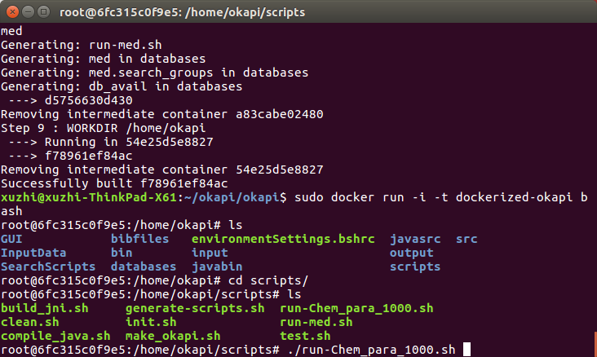
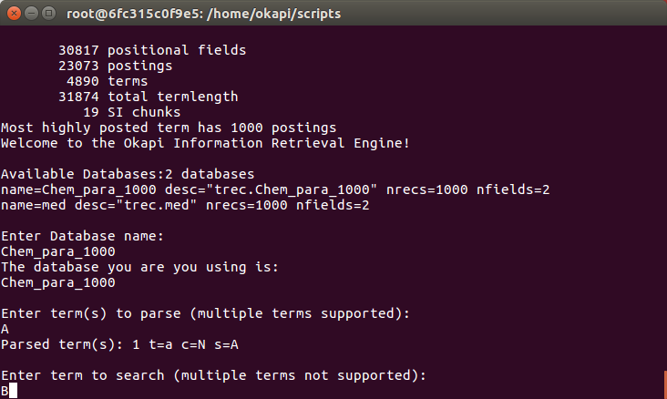

Add new exchange file to Okapi
If the Docker image is running with mount folder, new exchange file could be added to Okapi database list while Docker container is up and running. In the previous example of “Run Docker image with folder mount”, the folder named “/home/xuzhi/okapi/okapi/InputData” on host has been mounted to “/home/okapi/input” in Docker container. Adding an Okapi exchange file to this specific host folder, the exchange file will show up in mount folder in Docker container. There is a script named “generate-scripts.sh”, which will read “/home/okapi/input” folder in Docker container and generate parameter files and running script for all exchange files in this folder.
./ generate-scripts.sh

Mount Google Drive folder
As one of the best network driver, folder in Google Drive could be mounted to Ubuntu.
Mount Google folder to Ubuntu
sudo google-drive-ocamlfuse –o allow_other /home/xuzhi/okap/google-drive
Mount Google folder to Ubuntu
sudo docker run -i –t –v /home/xuzhi/google-drive/Okapi/InputData:/home/okapi/input dockerized-okapi bash

Use Talend to Generate Okapi Exchange file

Install Talend
Download and install “Talend Open Studio - Data Integration”
https://www.talend.com/download/talend-open-studio#t4
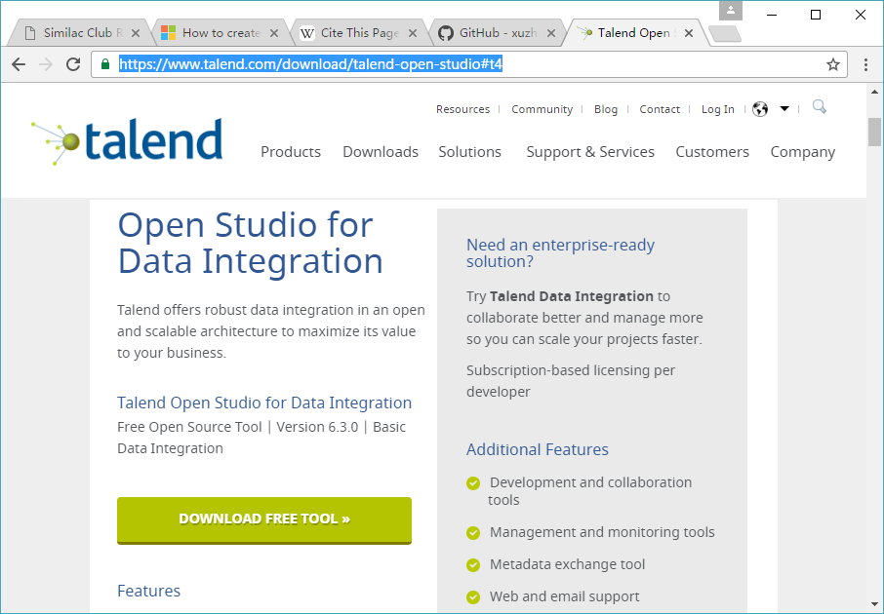

Execute TOS_DI-win-x86_64.exe or TOS_DI-win32-x86.exe to start Talend.
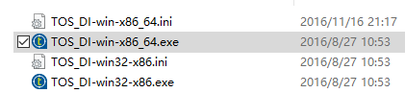

Import Talend project
The instruction of how to import Talend project could be found by using following link.
https://help.talend.com/display/TalendDataIntegrationGettingStartedGuide60EN/1.3.4+How+to+import+local+projects
In Talend Studio, you can import projects which are already created.
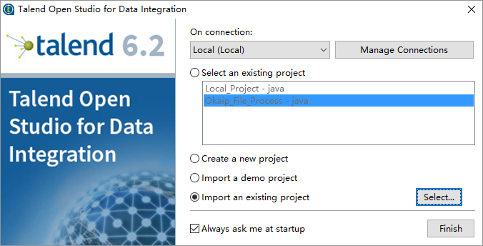
The existing project could be downloaded by using following URL from github
https://github.com/xuzhii/okapi/blob/master/okapi_talend_project.zip

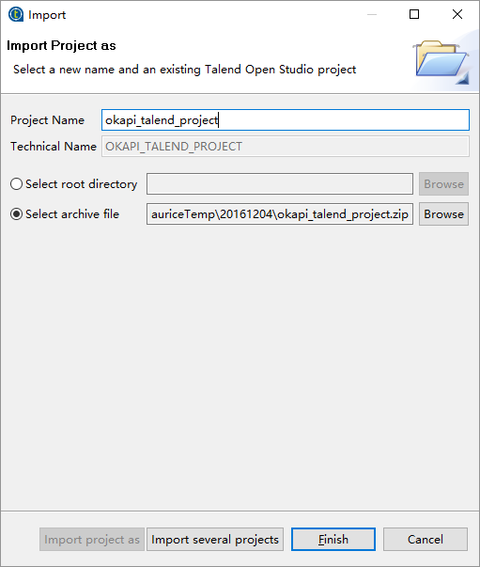
From the Studio login window, select Import an existing project then click Select to open the [Import] wizard.
Click the Import project as button and enter a name for your new project in the Project Name field.
Click Select root directory or Select archive file depending on the source you want to import from.
Click Finish to validate the operation and return to the login window.
Once the project is imported, project name could be found in the title bar of Talend Open Studio for Data Integration. In our case, it is Okapi_File_Process.
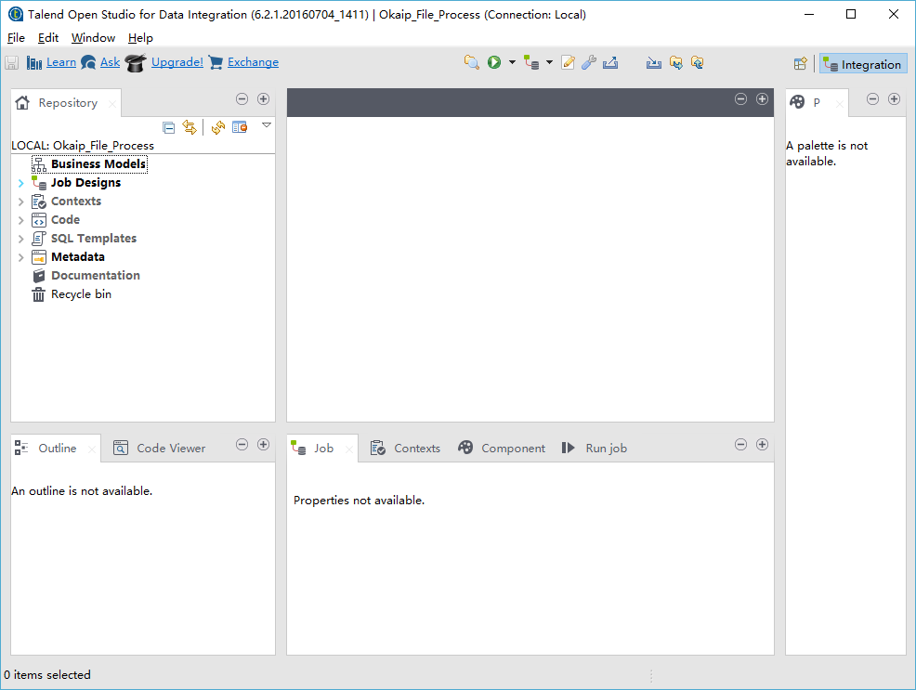

Setup Contexts
Before execute jobs in Talend, context values need to be updated or confirmed to specify input and output folders.
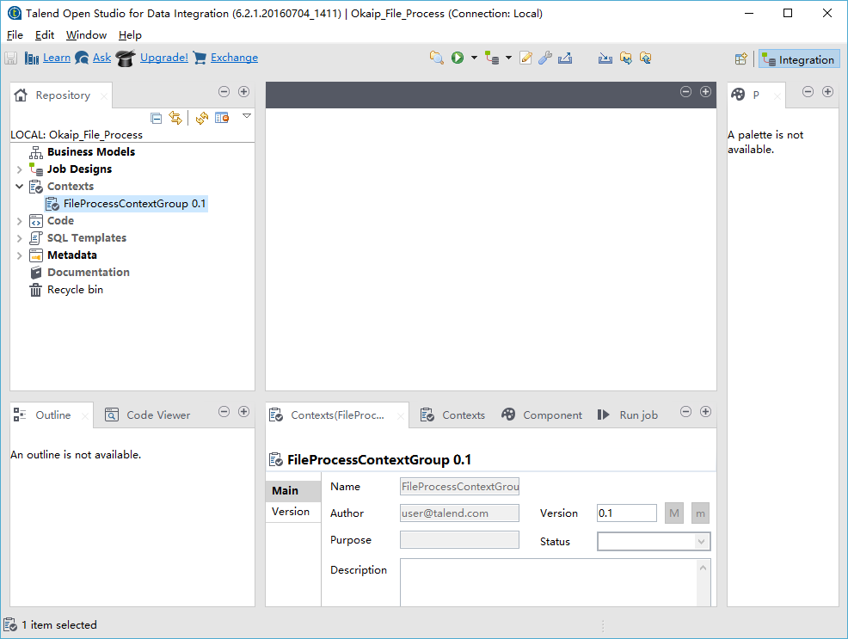
Select “Edit context group”
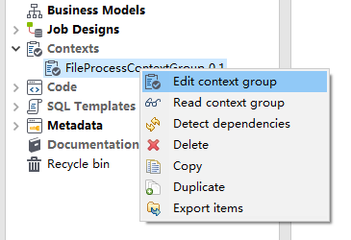
Click “Next”.
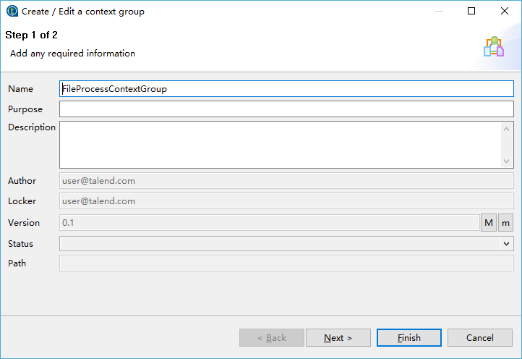
- SPLIT_INPUT_DIR: Raw data file input folder. Files in this folder will be split into several documents and saved in SPLIT_OUTPUT_DIR folder for further processing.
- SPLIT_OUTPUT_DIR: Raw data file output folder.
- PROCESS_INPUT_DIR: Document file input folder. Files in this folder will be processed and transformed into Okapi format and saved in PROCESS _OUTPUT_DIR folder for further processing.
- PROCESS_OUTPUT_DIR: Document file output folder.
- COMBINE_INPUT_DIR: Processed Document file input folder. Files in this folder will be combined into Okapi exchange format and saved in COMBINE OUTPUT_DIR folder for Okapi system to read.
- COMBINE_OUTPUT_DIR: Exchange file output folder.
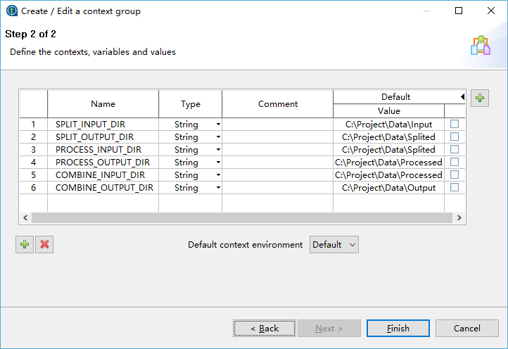

Execute jobs for dataset
Since different dataset have different format and syntax, in order to split raw data file, a customized split job must be defined.
Before execute jobs, make sure there is a split job defined for the dataset. For example, there is a dataset named “AP88-89”. A split job must be defined for this “AP88-89” dataset.
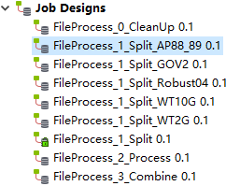

Copy raw data files into split input folder which is defined in Context. In our case, it is “C:\Project\Data\Input”
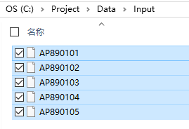
Execute following jobs in sequence and make sure all of them are running successfully.
- FileProcess_0_CleanUp: Clean temporary folders
- FileProcess_1_Split_AP88_89: Split raw data of dataset AP88_89 into document files, in addition process documents by removing some invalid tags, replacing special characters, etc.
- FileProcess_2_Process: Process document file
- FileProcess_3_Combine: Combine document files into Okapi Exchange file

Sample Clean up job: FileProcess_0_CleanUp
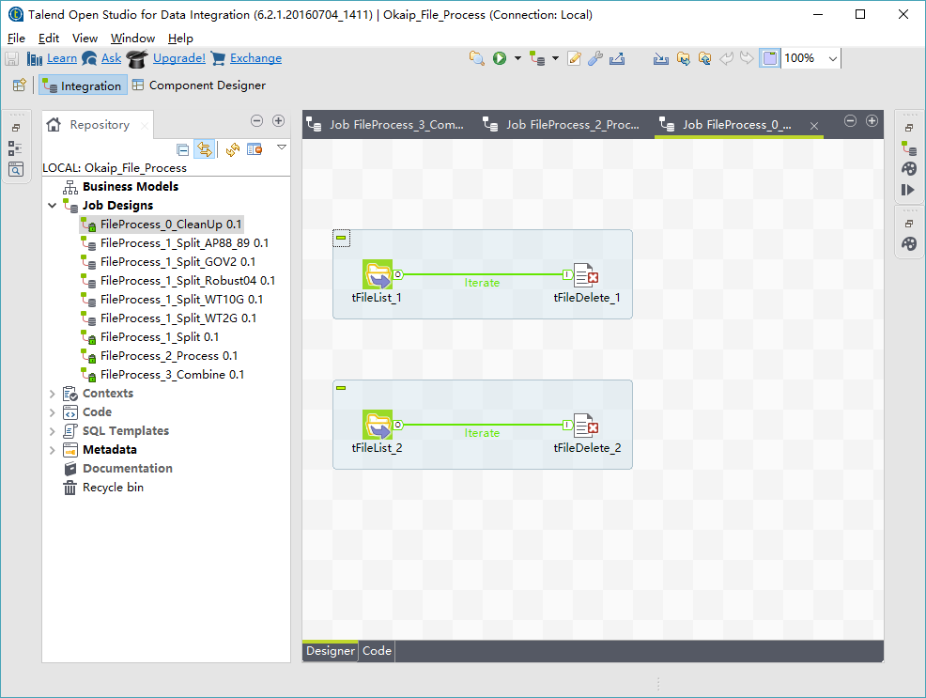
If “Run job” view is not show up, use “Windows” -> “Show view …” to add the view to GUI.
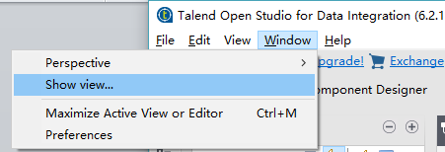
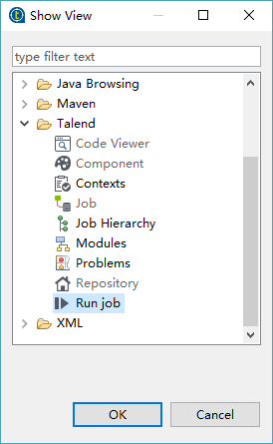

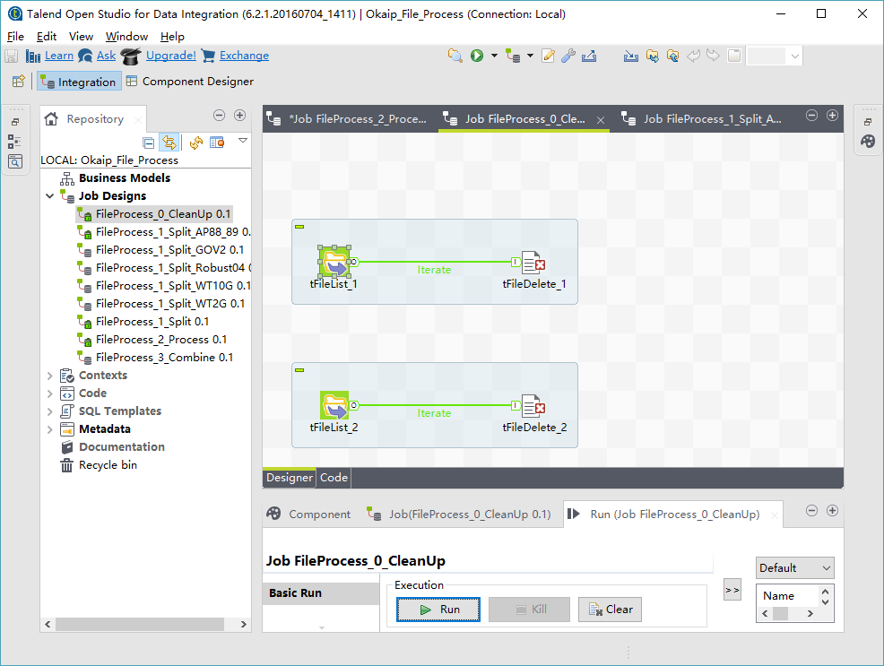
Return code 0 means the job was executed successfully.
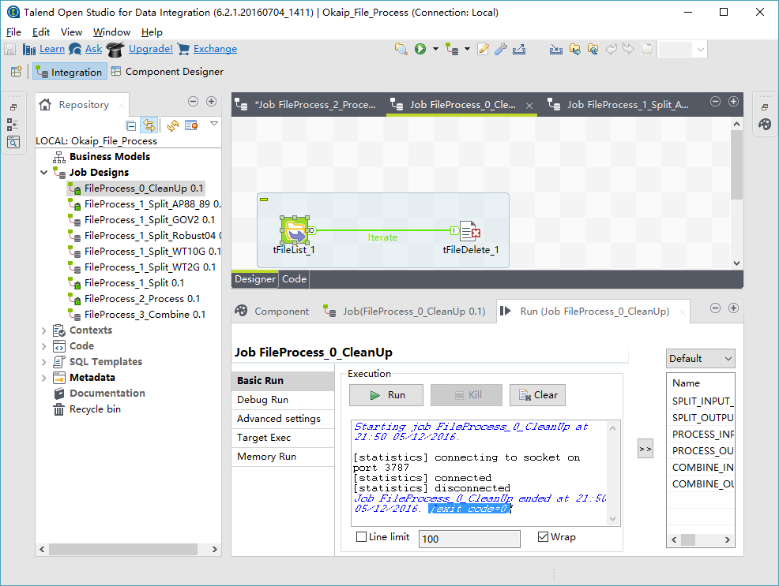

There is another way of executing the job.
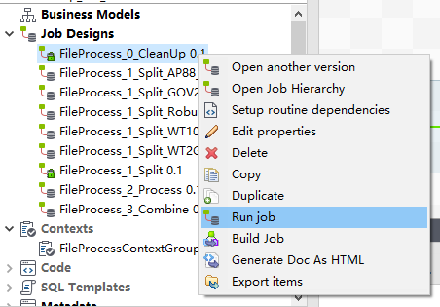

Sample split job: FileProcess_1_Split_AP88_89
This job reads files in the input folder and split them into document files by using tJavaRow component. In tJavaRow component, some Java codes will be executed to process input files.
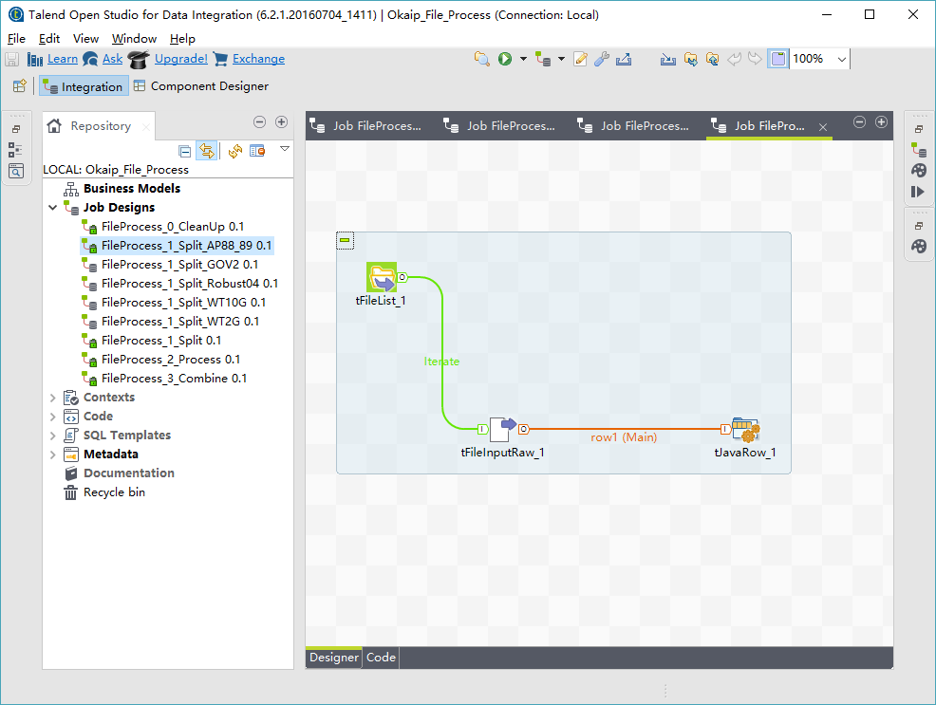
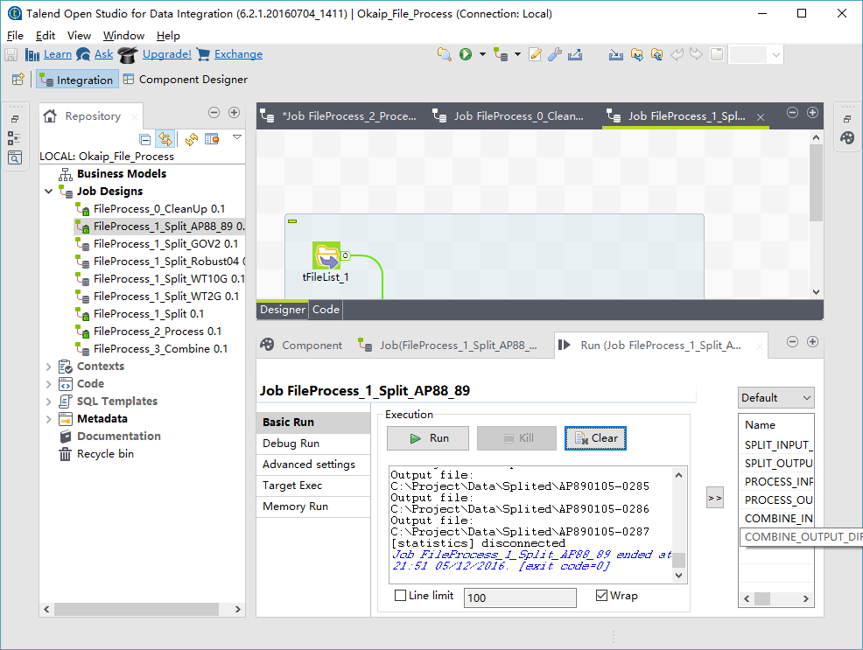
There are two Routines / Classes defined in the project. In order to add more functionality, more Routines / Classes could be defined in “Code” and used in tJavaRow component. For example, a Java Class named OkapiDoc is defined to split document based on tag name and remove invalid tags.
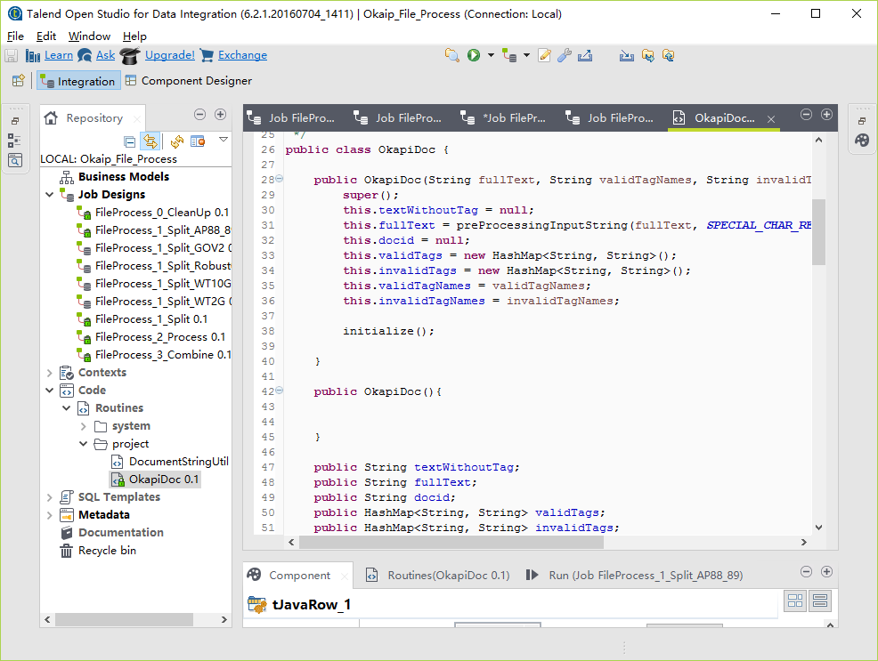

Sample process job: FileProcess_2_Process
This job process the input documents by replacing special characters by using tReplace component or doing any string operation by using tJavaRow component.
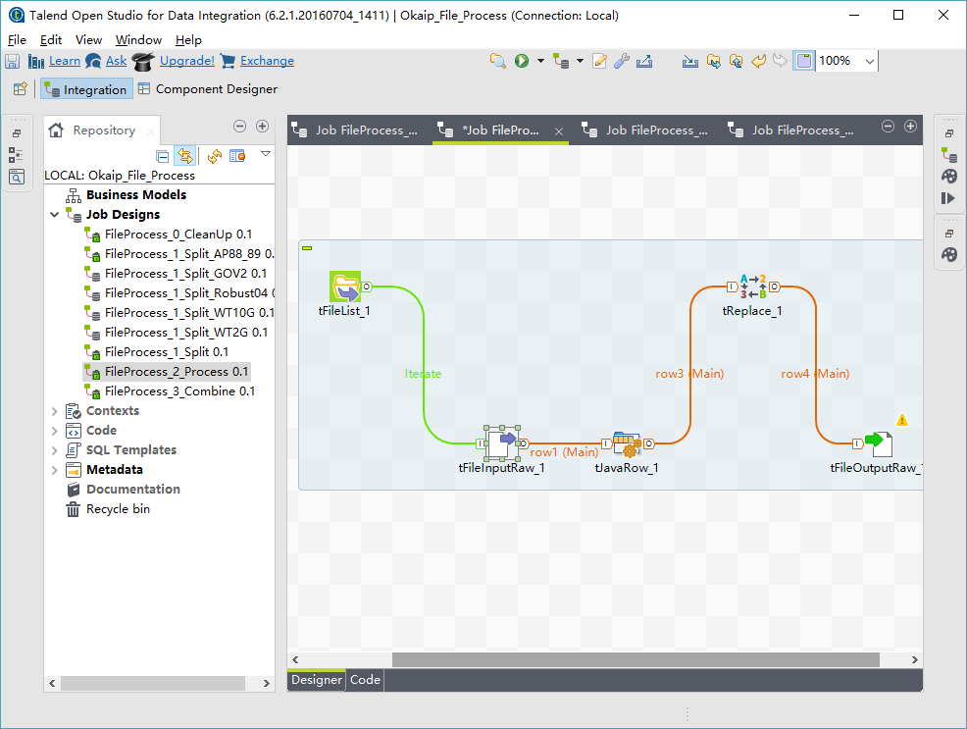
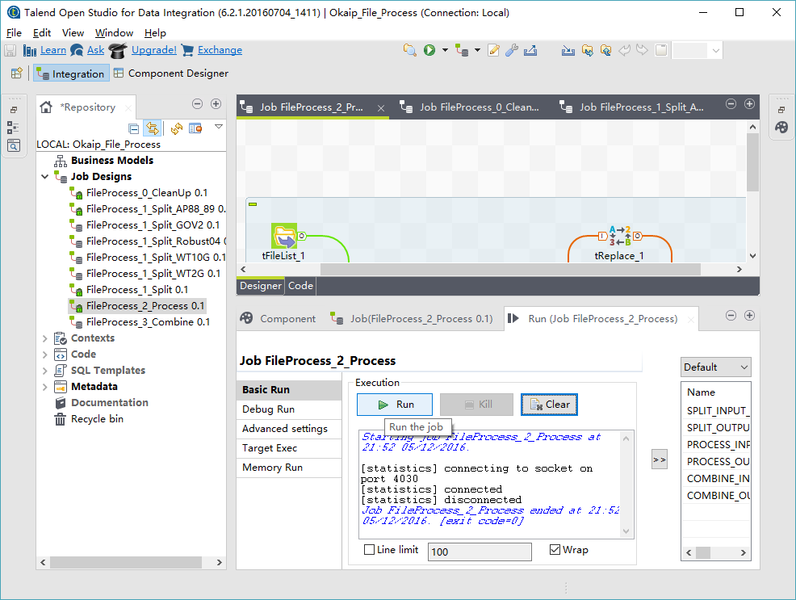

tJavaRow component could be used to any string conversion by utilize Java code.
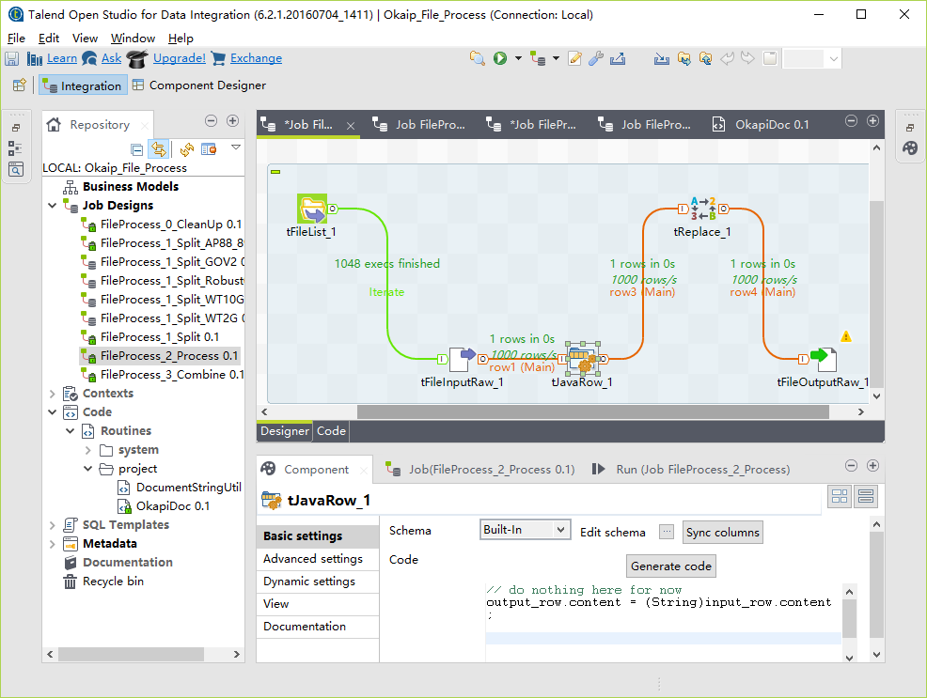
tReplace component could be used to replace characters or string by using regular expression. For example, it could be used to replace line feed character with single space.
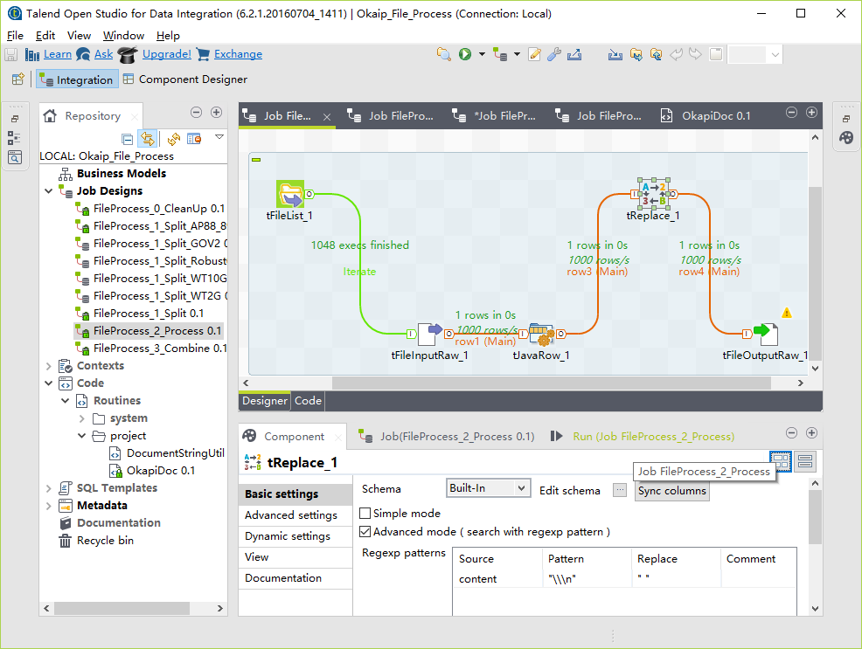

Sample combine job: FileProcess_3_Combine
This is a simple job which combines all files in its input folder to a single exchange file in its output folder.
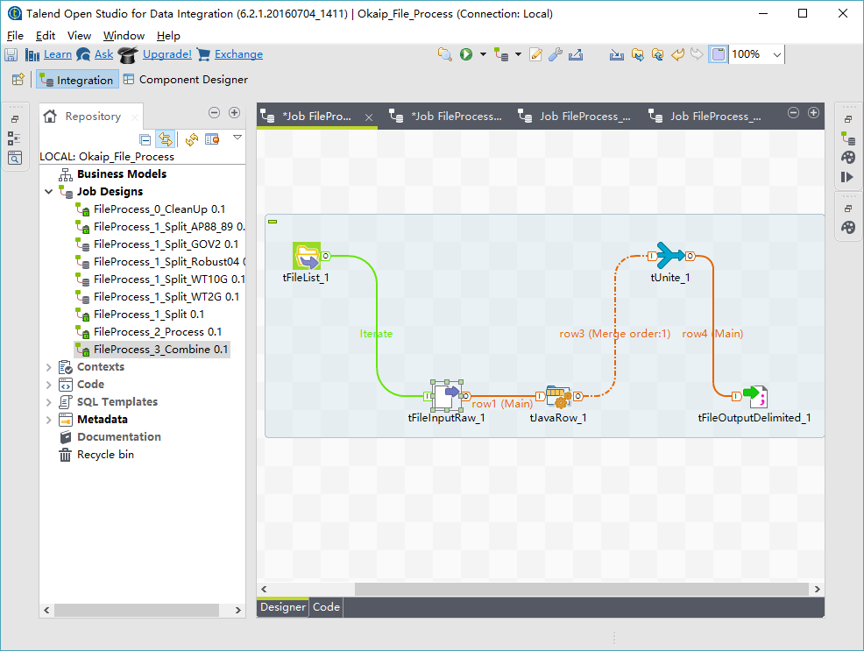
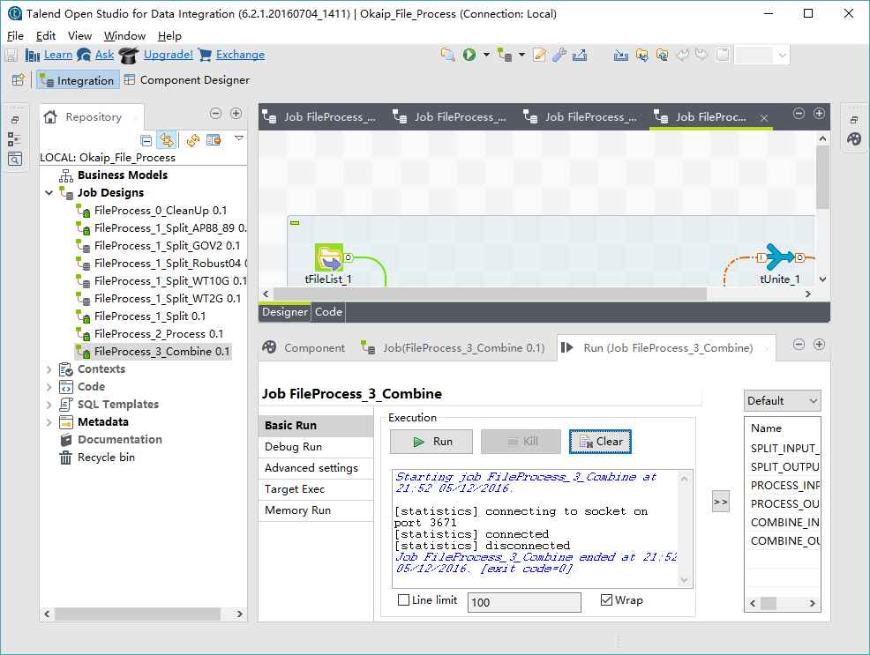
Once combine job is executed successfully, an Okapi exchange output file could be found in the output folder. The file name is output.exch and folder name is based on recent timestamp.
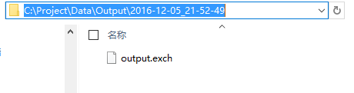

Customize split job for different dataset
In order to customize split job, please update tJavaRow_1 component in split jobs. Basically, many customizations could be done by passing different tag names to OkapiDoc class. This class uses a tag name to split documents in input raw data file and remove some invalid tags from those files. In addition, it removes some tags in the document while leaving text between tags in the document.
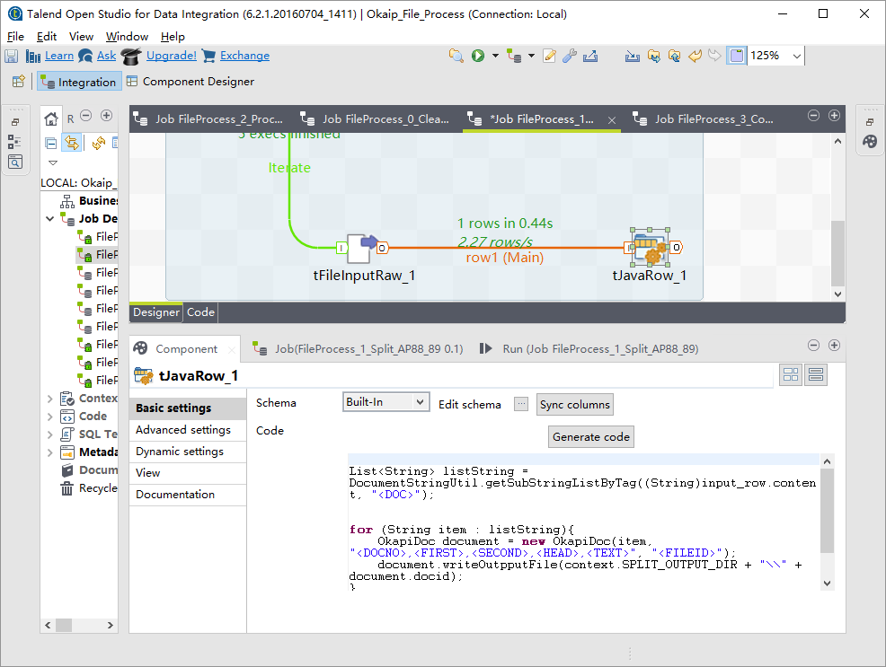

Execute jobs by using scripts
Once a job is defined properly and tested against target dataset, it could be exported from Talend and executed as script on Windows or Linux to improve performance. For details of how to export jobs from Talend Open studio, please see following instruction.
https://help.talend.com/display/KB/Exporting+a+Job+script+and+executing+it+outside+of+Talend+Studio

Conclusions
The project is highly beneficial. Since it is not a passive feature and can be adaptable to many types of projects & environments. It has no compromise in terms of document corpus quality as well. It is a great challenge to solve the Okapi IR system data preparing problem, but the outcome can be positive to the point of actually changing the IR analysis experiences of a lot of researchers.

Future Work
- New split jobs need to be defined for further dataset
- New Routine / Class could be defined to do further string processing
- Stemming functionality needs to be implemented in split or process job

REFERENCES

- Stephen E. Robertson, Steve Walker, Susan Jones, Micheline Hancock-Beaulieu, and Mike Gatford. 1994 Okapi at TREC-3. In Proc. of the 3rd Text Retrieval Conference (TREC). Gaithersburg, USA.
- Beaulieu, M., Gatford, M., Huang, X., Robertson, S., Walker, S., and Williams, P. 1996. Okapi at TREC-5. In Proc. of the 5th Text Retrieval Conference. NIST Special Publication SP, 143–166.
- Huang, X., Wen, M., An, A., and Huang, Y. R. 2006. A Platform for Okapi-based Contextual Information Retrieval. In Proc. of the 29th International ACM SIGIR Conference on Research and Development in Information Retrieval. ACM, New York, NY, 728.
- Zhao, J., Huang, X. J. and Ye, Z. 2014. Modeling Term Associations for Probabilistic Information Retrieval. ACM Transactions on Information Systems (TOIS). ACM Publisher. Vol 32, No. 2, Article 7, 47 pages.
- Wikipedia contributors. "Talend." Wikipedia, The Free Encyclopedia. Wikipedia, The Free Encyclopedia, 3 Dec. 2016. Web. 3 Dec. 2016.

